Lab 2: HDFS

-ls

List the content of the root directory

-mkdir

Create a new directory called “lab2” under the root directory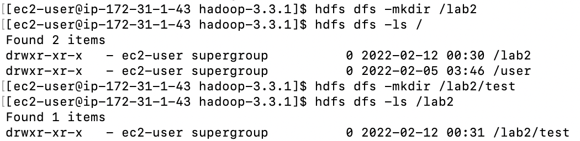

Create a new directory called “test” under the “lab2” directory

-rmdir

Remove the “test” directory from the “lab2” directory

-rm (done after -put)

Remove the “capacity-scheduler.xml” file from the “lab2” directory

-put

Upload the file called “hello.txt” (created in Lab 1 and stored under the EC2 /dsci551 directory) to the “lab2” directory

Upload the file called “capacity-scheduler.xml” (stored under the EC2 /hadoop-3.3.1/etc/hadoop directory) to the “lab2” directory

-get

Download the “hello.txt” file from the “lab2” directory to the EC2 /hadoop-3.3.1/etc/hadoop directory

-cp

Copy the “hello.txt” file from the “lab2” directory to the “user” directory as “copied_hello.txt”

-cat

Print the content of the “copied_hello.txt” file